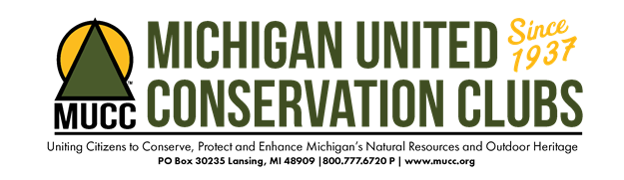
Michigan United Conservation Clubs
Location: Lansing, MI
Position: Club Administrator
Mission: Founded in 1937, Michigan United Conservation Clubs is the largest statewide conservation organization in Michigan. Our mission is to unite citizens to conserve, protect and enhance Michigan’s natural resources and outdoor heritage
Organizational Values:
- Fosters a conservation stewardship ethic in the public
- Protects the rights of the public to hunt, fish, trap and recreate outdoors
- Encourages the public to connect to our resources through active recreation
- Advocates for sustainable conservation practices and resource stewardship through sound scientific management.
Part-Time, Flexible Hours - $12.00-$16.00/hour depending on experience, rarely exceeding 28 hours/week.
Reports to: Executive Director
Job Goals:
- Fosters a conservation stewardship ethic in the public through engagement with our 200+ affiliated clubs.
- Creates a sense of connection and belonging between affiliate clubs and MUCC as the parent organization.
- Enable MUCC to be more engaged with club affiliations and charitable gaming oversight.

Job Overview:
Management and oversight of the organization’s club membership process. Including importing club rosters, club affiliation, disaffiliation and database administration.
Responsibilities include but are not limited to:
Administration-Prioritize MUCC’s club relationships
- Enter club roster data into Neon (organizational database)
- Import member data
- Update club affiliation maps
- Implement a club affiliation packet
- Send and process dues renewal reminders
- Assist membership coordinator with Club sign up for TRACKS/MOOD Magazine
- Manage oversight of MUCC/Club charitable gaming relationship
- All other duties as assigned
Field Work-Promote MUCC club membership with the public.
-Work directly with club representatives to keep clubs up to date with affiliation
- Periodically attend MUCC and club meetings, outdoor shows, outreach events to promote the benefits of club membership within MUCC.
Office- Completion of daily tasks
- Answering office phones and monitoring emails
- Assistance with mailing and fundraising efforts
- Retrieving and shipping club membership mailings
Minimum Education & Skills- High school diploma
- Highly organized
- Strong writing abilities
- Strong customer service background and phone etiquette
- Experience using MS Office and Google Suite
- Ability to see projects through from creation to completion
- Ability to work independently
- Ability to handle multiple priorities
- Ability to work as part of a team
- 1st aid/CPR certified, or willingness to become certified
- Knowledge of hunting, fishing and conservation or willingness to learn
Miscellaneous:
Must have a reliable form of transportation including insurance and driver’s license.
Must have reliable high-speed internet in case MUCC continues to work from home during the pandemic.
MUCC is an equal opportunity employer and values diversity. All employment is decided on the basis of qualifications, merit and business need.

