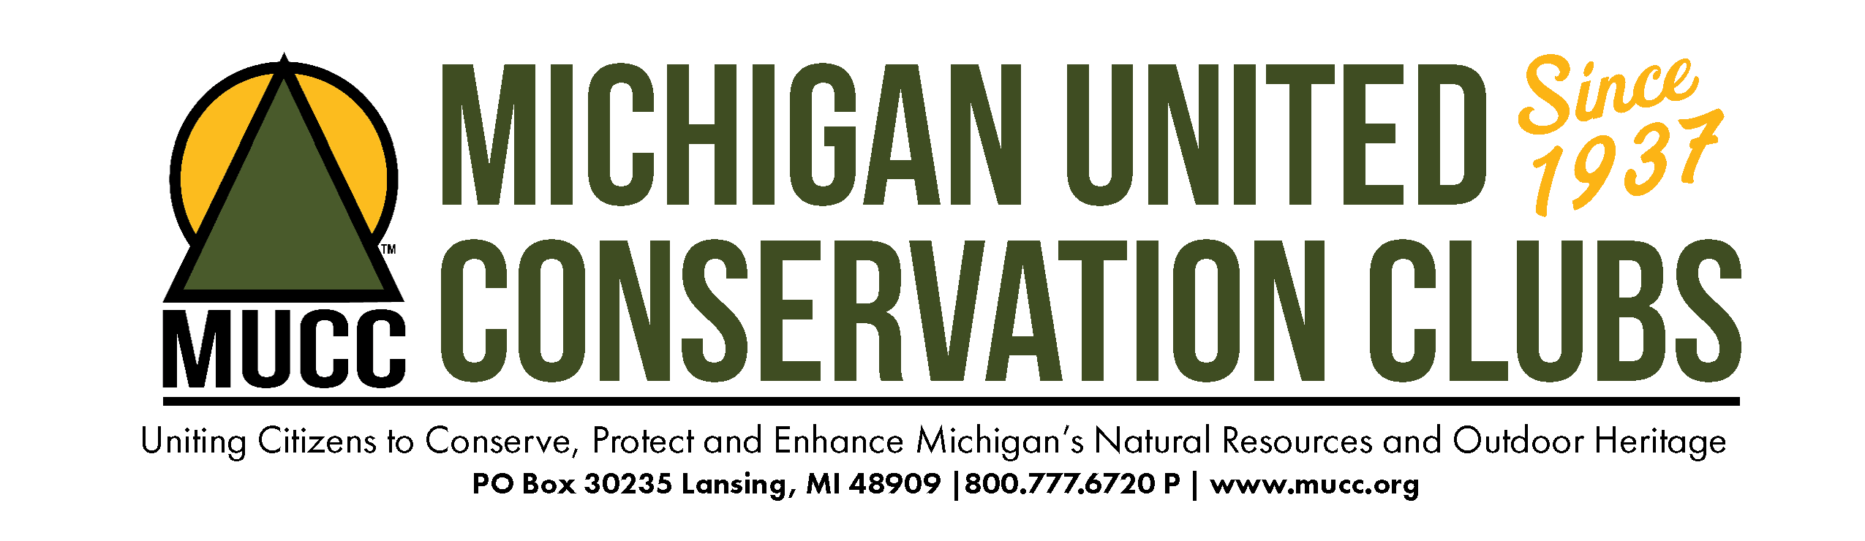

2021 Policy Resolutions Status
Passed Resolutions
#1: ALLOW HUNTERS ONE LEFTOVER SPRING TURKEY TAG
Submitted by: Zach Snyder, Individual Member
Michigan United Conservation Clubs will work with the Michigan Department of Natural Resources and the Michigan Natural Resources Commission to allow spring turkey hunters the opportunity to purchase one leftover turkey tag in addition to their already purchased tag when leftover tags become made available to the general public.
#2: CHANGE THE DEER MANAGEMENT PHILOSOPHY IN THE LOWER PENINSULA
Submitted by: Charles Felcyn
Michigan United Conservation Clubs (MUCC) work with the Department of Natural Resources (DNR) and Natural Resources Commission (NRC), to manage Michigan’s deer herd for health, buck to doe ratio, and quality not quantity. MUCC will support changes that would implement a three-year trial of a regulation that would:
- Offer a discounted doe tag with the combination license (3 tags), in DMUs where antlerless harvest is valid; and,
- That the DNR and NRC provide sufficient additional antlerless tags to meet the needs of managing the deer herd in the Deer Management Units (DMU).

#3: RECESS IN K-5 SCHOOL

Submitted by: Dawn Levey, Region 5 Executive Board member
Michigan United Conservation Clubs work with the Michigan State Legislature and the Michigan Department of Education to educate and encourage the development of standards and curriculum to maintain designated time during the school day for outside play/recess (without reducing the lunchtime schedule) for the wellbeing of Michigan’s greatest natural resource, its children.

#5: A RESOLUTION TO PROPOSE A STATE TAX CREDIT FOR THE DONATION AND PROCESSING OF LEGALLY HARVESTED DEER TO FEED THE HUNGRY OF OUR STATE
Submitted by: Dean Hall, Michigan Sportsmen Against Hunger
MUCC support legislation to create a state tax credit per each deer legally harvested during a hunting season by a hunter and donated to a charitable organization like the MSAH that is engaged in the distributing wild game processed at a Michigan Department of Agriculture and Rural Development (MDARD) or United States Department of Agriculture (USDA) inspected and approved participating wild game processors in our state.
MUCC will support legislation to also create a tax credit per each donated and legally harvested deer that is processed into ground venison burger by a processor to feed the state’s hungry through working with a charitable organization like the MSAH that is engaged in the distributing wild game processed at an MDARD or USDA inspected wild game processor to feed the hungry of our state through the state of Michigan recognized non-profit food banks, shelters, and pantries.

#6: FERAL CATS AS AN INVASIVE SPECIES
Submitted by: Greg Peter, MUCC President
MUCC will support the designation of feral cats as an invasive species and thereby subject to regulation as such.

#7: FURTHER MEASURES TO FACILITATE THE ELIMINATION OF FERAL SWINE
Submitted by: Greg Peter, MUCC President
MUCC advocate for all strains of swine to be banned from game preserves for the purposes of hunting.

#10: CLARIFY ATV HELMET LAWS

Submitted by: Joe Sommers, U.P. Whitetails of Marquette County

MUCC shall work with the Michigan Legislature and Michigan Department of Natural Resources to change necessary state regulations such that the adult rider, driver or occupant of an all-terrain vehicle (ATV), quad or 4-wheeler not be required to wear a helmet.

#12: WORK WITH THE MDNR TO ADD FREE FISHING ON MOTHER’S DAY
Submitted by: Patrick Hogan and Tim Muir Jr.
MUCC work with the Michigan legislature and request from the MDNR that additional free fishing weekends in the spring be aligned with Mother’s Day in an effort to increase participation in fishing.

#13: CONVENIENT LOW OR NO COST CWD TESTING
Submitted by: Erik Schnelle, State Advisory Council President, National Deer Association
MUCC encourage and support the funding and provision of convenient, low or no cost testing for Chronic Wasting Disease in known CWD areas of Michigan.

#14: THE USE OF TROTLINES, SETLINES, AND JUGLINES AS A METHOD OF TAKE FOR FISH AND TURTLES
Submitted by: Greg Peter, MUCC Vice President
MUCC oppose the use of trotlines, setlines, and juglines as a method of take regardless of the number of hooks used.
#15: ENCOURAGE MI DNR TO FURTHER ENGAGE OPPORTUNITIES OF COLLABORATION WITHIN THE MICHIGAN TRAIL SYSTEMS BY UTILIZING CITIZEN SCIENCE DATA COLLECTION FOR NATURAL RESOURCES MANAGEMENT
Submitted by: Mark Hergenreder, Chelsea Rod and Gun Club
MUCC encourages the Michigan DNR to further establish an opportunity for detailed data points to be registered quickly and shared easily with users utilizing a community driven application.

Withdrawn Resolutions
#8: LOGGING QUIET TIME
Submitted by: Leonard Shaner

Michigan United Conservation Clubs (MUCC) remain an advocate for the hunter and the use of State Forest lands for people to enjoy this time of year. To this end, MUCC should work with the Department of Natural Resources Forestry Division and the Wildlife Division to modify logging permits so as to close all state forest to logging operations during the month of November to allow hunters to enjoy the peace and quiet of State Forest lands without interference of logging companies and their employees.

Failed Resolutions
#4: RESTORING TAGS IN DISEASE AREAS
Submitted by: Erik Schnelle
Michigan United Conservation Clubs (MUCC) work with the Department of Natural Resources (DNR) and Natural Resources Commission (NRC), to restore the antler point restriction in the combination license.

#9: REDUCED YOUTH HUNTING FEES
Submitted by: Chelsea Rod and Gun Club
Michigan United Conservation Clubs use its influence to urge the Michigan DNR and the state legislature to reduce hunting license fees for youth hunters under the age of 16 to a level equal to or less than the fees paid by senior hunter.

#11: CHANGE THE MINIMUM SIZE LIMIT AND CHANGE THE POSSESSION LIMIT OF NORTHERN PIKE ON INLAND LAKES IN THE UPPER PENINSULA
Submitted by: Straits Area Sportsmen’s Club, Gary Gorniak & Steve Dey
Michigan United Conservation Clubs (MUCC) work with the Department of Natural Resources (DNR) and Natural Resources Commission (NRC) to change the Northern Pike regulations on Inland Lakes in the Upper Peninsula to no MSL and the limit to five (5) with only one (1) being 24 inches or greater.

#16: ESTABLISHMENT OF AN ANNUAL YELLOW PERCH SEASON FROM APRIL 26 TO MARCH 14
MUCC work with the Michigan Department of Natural Resources to establish a yellow perch possession season from the last Saturday in April to March 15 in MM4 and MM5 to allow for natural reproduction.

