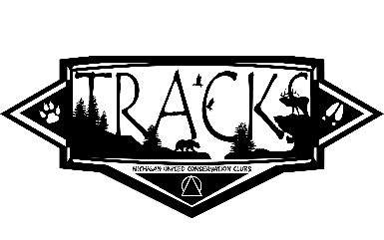
CLASSROOM ORDER FORM FOR TRACKSTM MAGAZINE
2022-2023 School Year

Michigan United Conservation Clubs (MUCC) would like to thank you for your interest in TRACKS. TRACKS is an upper-elementary reader featuring articles in every issue on wildlife, energy, ecosystems, taxonomy, habitat, biology, careers and conservation. TRACKS uses Next Generation Science Standards, while teaching youth about Great Lakes wildlife.

TRACKS is available from October through May for $6.00 per student.
Subscription rates for 10 or more issues per classroom are adjusted if you sign up for a subscription after October. See the table below for adjusted classroom rates.

You may also order an individual subscription for $20.00.

Checks, purchase orders, Visa, Discover, or MasterCard accepted.
Contact Sue Pride by phone at 1-800-777-6720 or Email at spride@mucc.org to pay via card.
Make checks payable to MUCC and mail to P.O. Box 30235, Lansing, Michigan 48909

Adjusted Classroom Rates:
Subscription Start Date | Price Per Student
October | $6.00
November | $5.75
December | $5.50
January | $5.25

ORDERS OF TEN OR MORE
Purchaser’s Name ______________________________________ Phone __________________
Purchased For:
Teacher’s Name ___________________Email_____________________ # TRACKS Issues _____
School Name ___________________________________________________________________
School Address _________________________________________________________________
City ____________________________________ State ____________ Zip Code _____________

Additional teachers at same school (use additional sheet if necessary):
Teacher’s Name ______________________Email_________________________#TRACKS--------
Teacher’s Name ______________________Email_________________________#TRACKS_____
Teacher’s Name ______________________Email_________________________#TRACKS_____
Teacher’s Name ______________________Email________________________ #TRACKS_____

